**Critical Analysis Task Rubric**

Given the critical analysis task notebook, you need to complete a report with no more than 1,200 words and 10 images at most. Your task is to identify issues in the notebook file to improve the project quality. Detailed instructions on how to compose the report are provided in the critical a[nalysis task requirement](https://ilearn.mq.edu.au/mod/page/view.php?id=7230479). Your critical analysis task will be marked based on the following rubric.

 ·       Identifies problems with the notebook at suggest ways that it might be improved (12 marks in total)

* + Up to 4 marks per issue. The mark per issue is based on whether you have:
  + 1 Clearly explains the problem and why it is an issue
  + 2 Suggests a change to the notebook that would resolve the issue
  + 3 If appropriate, includes sample code or screenshots to illustrate the answer

You need to identify at least 3 issues to get full 12 marks. You are encouraged to identify more than 3 issues, but you still can at most get 12 marks. For example, if you identify 3 issues and each issue receives 4 marks (or if you identify 4 issues and each issue receives 3 marks), you can get 12 marks. But, you are not suggested to discuss too many issues because you will not receive a high mark for an issue if you fail to sufficiently explain the issue.

·       Well written and communicates clearly (3 marks)

* + Use of headings, paragraphs and figures to present a readable report
  + No spelling or grammatical errors
  + Report includes useful introduction and summary sections

**Requirement of Critical Analysis Task:**

You will be given a dataset and a Jupyter notebook file that processes the dataset, data cleaning, train machine learning models, model evaluation and result visualisation. The files are give by me

The provided critical analysis notebook contains the description of the dataset, the basic instructions of each step and python code to process the dataset. However, there are many issues in the notebook project which should be refined to improve the notebook quality. Your task is to read the notebook and understand what the project is doing. Based on your understanding, you need to complete the following tasks.

·       Based on the knowledge you have learned from this unit, you need to identify the issues in the notebook project which should be revised.

·       Clearly discuss and explain why an issue is a problem for the project.

·       Provide argument to revise the notebook. If necessary, you can revise the python code.

 Note that you do not need to consider which model is better for solving the problem or what insights can be obtained from each project. You should focus on whether each step can correctly process the data records and correctly train the model.

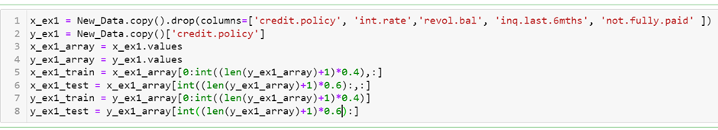Below is an example to guide you how to conduct critical analysis task.

In this example, 40% records are allocated for model training while 60% records are allocated for testing. This is not a correct way to generate training and test datasets. If the number of records in the training set is too small, it is difficult to train an accurate model. Inversely, if the number of records in the test set is too small, the model cannot be sufficiently evaluated for its performance. The rule of thumb is to put 90% records into the training set and leave the rest 20% record as the test set.  The 10-fold cross validation is adopted by randomly split the dataset into 10 equal-size subsets. Each subset will be used as the test set for each evaluation case. A revised solution is

